1. Open- https://start.spring.io/

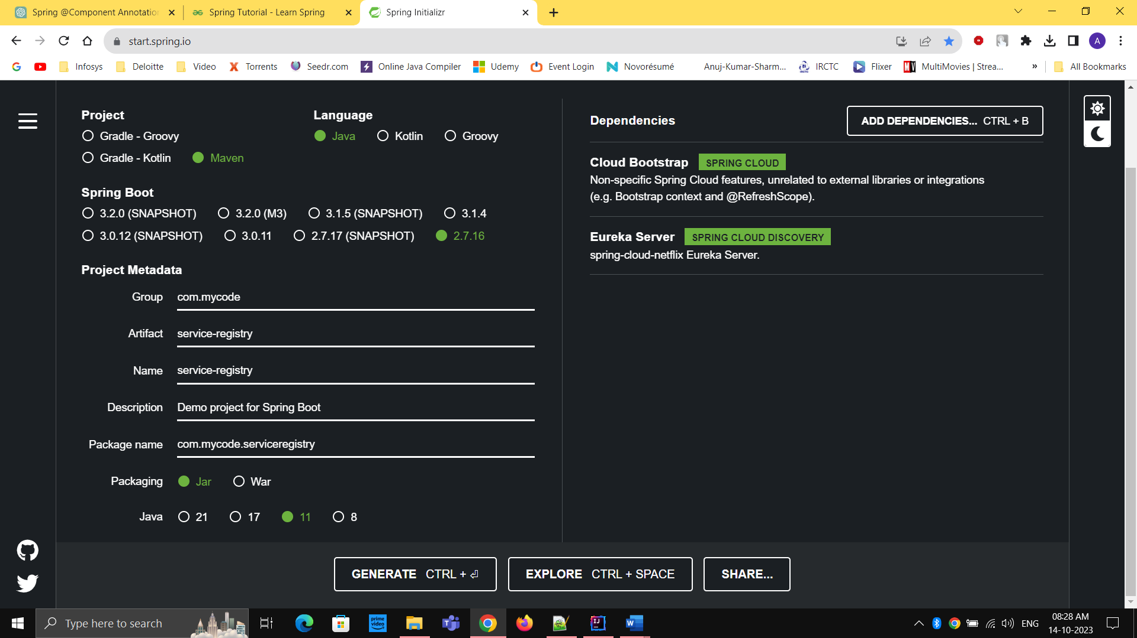

1. Open Main class (ServiceRegistryApplication.java)

Add @EnableEurekaServer

1. Refactor application.properties to application.yaml

server:  
 port: 8761  
  
eureka:  
 instance:  
 hostname: localhost  
 client:  
 register-with-eureka: false  
 fetch-registry: false  
  
spring:  
 application:  
 name: SERVICE-REGISTRY